fall 2024
Cse-4355/5355 Electromechanical Systems and Sensors
the university of texas at arlington


lab 4 report
Submitted toward the partial completion of the requirements for CSE 4355/5355
Under the guidance of
Prof. Jason Losh
By:
Dario Ugalde, 1001268068
Joshua Martinez, 1001374818

Introduction
This lab introduces and focuses on a brushless DC motor, or BLDC. In this lab, a primary goal is to explore the electrical and physical rotations and their differences within this motor. From previous lab assignments, we learned about a stepper motor containing two coils and their dual rotational patterns. In this lab, the BLDC will have three coils to explore. Within the motor, it also contains three hall effect sensors that help with track the position of the said coils. We will develop a better understanding about BLDC motors, their commutation behaviors, and their performances during operation.

Steps 1-3: BLDC Commutation
First step of the lab covers the initial setup for the circuit. There is a six-voltage requirement for the motor’s operation. The ground will serve as reference for the circuit but not for the coils, which will be explained later. The BLDC motor has an internal coil resistance of 0.13 ohms, but the ten-amp limit on the power supply limits the current, mainly for voltage spikes from the back emf. The coils within the motor are delta-wired, and a virtual ground is created by summing their values through a 100k ohm resistor. This ground is used when enabling two of the coils during the motor steps.
The next steps involve understanding the relationship between the motor’s electrical and mechanical rotational relationship. We will power one of the coil pairs at a time to measure the location of the motor pulley within degrees using a protractor. As a result, a full electrical rotation requires six steps, or sixty degrees each step. Since there are two coil pairs, a mechanical rotation needs two electrical rotations. This leads to 1 electrical step which is 60 degrees equaling 30 degrees in mechanical. The table below shows the recorded data when capturing the mechanical degrees based on the sensors in a future step. The sensor values roughly match the coil electrical steps polarities.

Degree | Sensor A | Sensor B | Sensor C
0 | 0 | 0 | 1
10 | 0 | 0 | 1
20 | 0 | 1 | 1
30 | 0 | 1 | 1
40 | 0 | 1 | 1
50 | 0 | 1 | 1
60 | 0 | 1 | 0
70 | 0 | 1 | 0
80 | 0 | 1 | 0
90 | 1 | 1 | 0
100 | 1 | 1 | 0
110 | 1 | 1 | 0
120 | 1 | 1 | 0
130 | 1 | 0 | 0
140 | 1 | 0 | 1
150 | 1 | 0 | 1
160 | 1 | 0 | 1
170 | 1 | 0 | 1
180 | 1 | 0 | 1

Table 1: Mechanical Rotation based on sensor table

Steps 4-6: Understanding Hall Effect Sensors
Afterwards, the next part of the lab introduces the usage of hall effect sensors. They are powered by a five-voltage source, which our microcontroller will supply. Their outputs are open drain and need to be connected to the five-voltage source through 10k ohm resistors. Using the oscilloscope to read the outputs of these sensors while rotating the motor pulley, we can display their outputs and compare them against the physical rotation relative to zero degrees. The noted angles the sensors turn on and off can be seen in figure 1 while the motor is rotating. These angles were captured through manually rotating for a reference in other steps. The next step to complete was recording the relationship between the sensor outputs based on which coil is energized. In figure 2, this relation was captured. The bottom three signals represent the hall effect sensors and were captured using a digital extension on the oscilloscope. The top three signals show the voltage outputs on coils while being energized and de-energized. This figure helps illustrate the relationship between the coils and the sensors. Approximately, the number of enabled sensors cycles between one and two. When a sensor is enabled or disabled, a coil is energized while one of the other two is turned off. This relation will be needed for a future step.

Figure 1: Electrical Rotation based on captured results through manual rotating
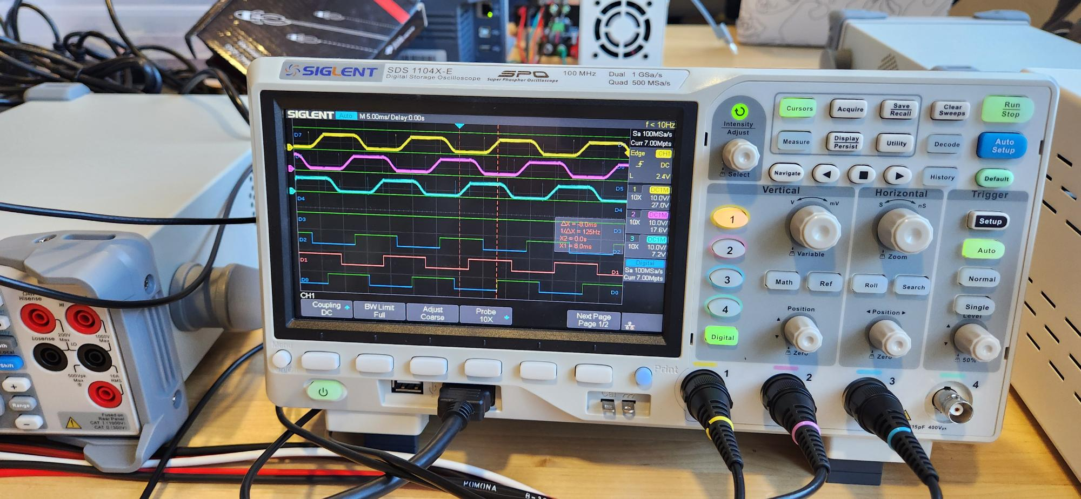
Figure 2: 6 signals representing coil voltages and sensor values

Steps 7-10: GPIO Control Loop
Once the relation of hall effect sensors and coils are understood, the next steps require adding 4 half H-bridges into the circuit to allow the microcontroller to control the motor. As there are three coils, only three of the four bridges will be needed. Each bridge will require a separate output for each coil and an enable, meaning a total of six pins from the board. The motor’s coils are energized when the correlating enable pin and direction pin are enabled in the h-bridge. The changing of these pins in the correct fashion can simulate stepping for the BLDC motor. When the circuit is completed, a program for the red board will cycle through the necessary states, or steps, of the motor coil and enables it to translate into the motor rotating. This loop program is made to change steps every second to ensure a proper state machine. Afterwards, the next step details decreasing the second time delay, thus increasing the motor speed. At a certain point, or time, the motor will rotate consistently. To ensure this time measurement is valid, a decent amount of load needs to be placed onto the pulley. If the motor falls out of sync easily, increase the time measurement. After testing for a while, we noted a 7000 microsecond wait allowed our motor to run steadily and properly despite pressure on the motor. This point creates the basis for the next steps.

Steps 11-12: Hall Effect Control Loop
For this step, our team’s code that implemented the GPIO control loop to perform the motor’s commutation will be expanded upon. The first part requires increasing the motor’s speed without slipping from our noted 7000 μs. This variable was made into a global one and was decreased within an if loop. The lowest time was 2790 ms. Thus, the fastest the motor could spin from no movement was 7000 μs and 2790 μs when ramping the motor’s speed. The next step details switching the commutation of the motor from a time-based loop to a hall effect sensor-based loop. This was accomplished by adding a while loop function after reaching the 2790 ms motor speed. The amperage and watts within the motor can be seen in figure 3 below. By leveraging our findings from earlier, this loop checks the overall sum of the GPIO inputs connected to the hall effect sensors to cycle through the states. The new code must preemptively enable the next step in the state machine to continuously rotate the motor shaft without delay. In other words, the number of sensors on at a given time is one or two. At the start of the while loop, it checks if one sensor is one; if so, it locks into another while loop, enabling the next step, and constantly rechecking the sensor values. Once the number of sensors changes, it exits the loop. The next if statement checks if two sensors are on and mirrors the first if statement. This simple while loop checking sensor values can rotate the motor at its fastest speed with the values of the power supply in figure 4 below. At this speed, the back emf voltage of a coil is needed to be measured and understood. Based on our findings, the voltage range shown by phase, or coil, C is between -.8V to 7.4V, or a range of about 8 volts, which represents the max voltage and the back emf voltage produced by the motor coil. The shape of the phase matches the signal as the top ones from figure 2. The reason for the trapezoidal shape is due to the winding construction of the motor. The windings cover a coil pair in either direction. When the magnet within the motor is cut from the energized coil, the emf is released at a constant magnitude because of the windings. The same could be said when the magnet attaches to an energized coil. The winding also introduces cogging torque within the motor. These are the minor steps that feel weaker than others which happened at testing early in the lab.

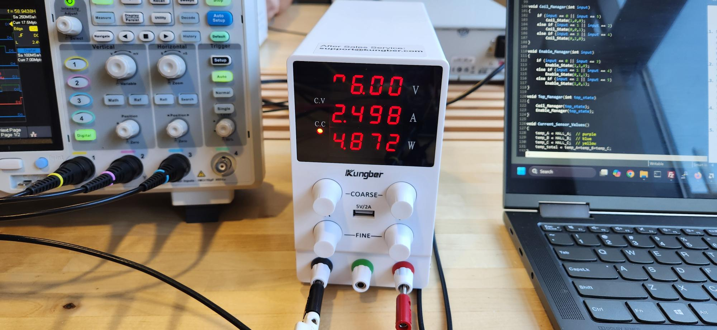
Figure 3: Power supply image during motor rotating at lowest rpm without hall effect sensors
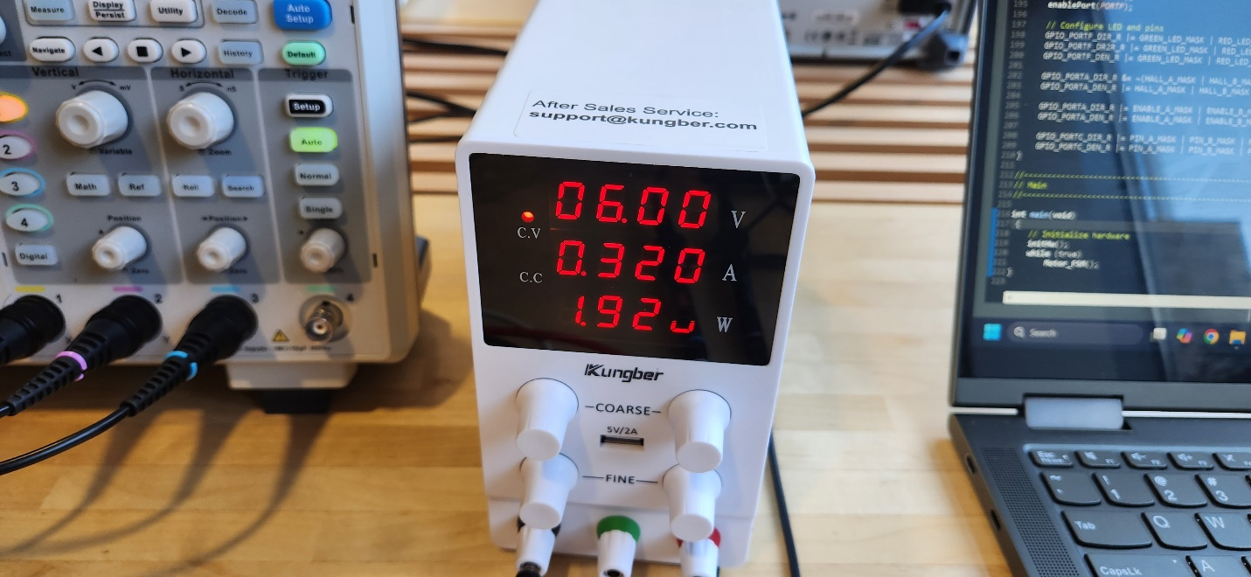

Figure 4: Power supply image during motor rotating using hall effect sensors

Steps 13-14: Digital Hall Effect Output

Our team was required to complete the additional lab steps as one of the members is enrolled in the graduate section of the course. These two steps required connecting additional components to our circuit. This new circuitry consisted of wiring up the analog output of the hall effect sensors and passing the signal through a comparator to generate a digital output using the virtual common of the motor as the threshold value. This addition can be seen in figure 6 below. This digital signal can then be used to obtain additional information about the motor, such as: rotary position and rotational speed. The relation of the hall effect sensors to their comparator offset values can be seen in figure 7 below. During testing, our circuit provided a clean digital output without spikes at around 8700 RPM.

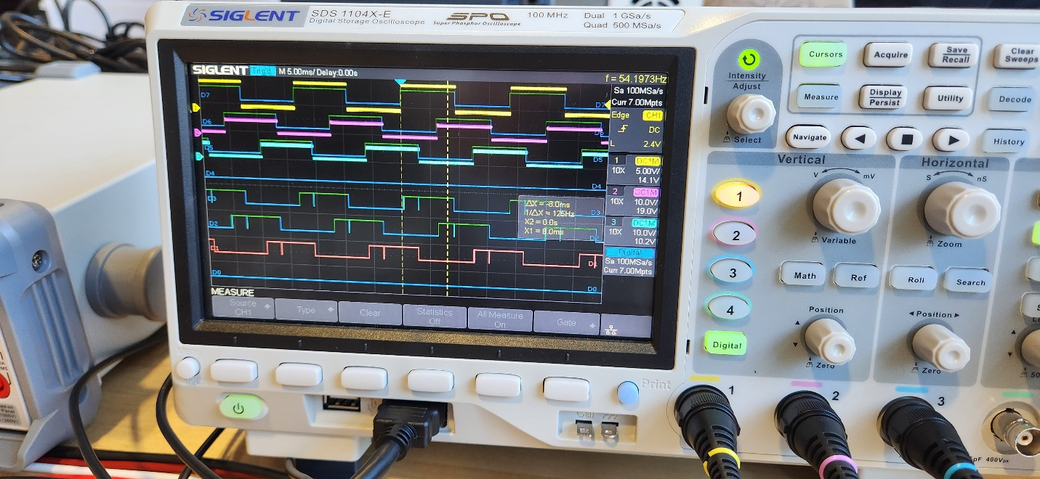

Figure 5: Oscilloscope illustrating the phase shift of the hall effect sensor output with their correlating offset values

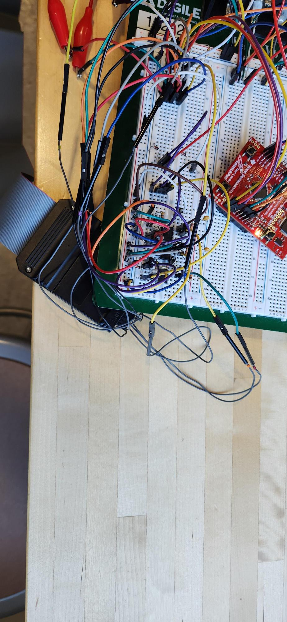
Figure 6: Image of comparator circuit used for lab

Conclusion
This lab provided a practical approach in understanding the commutation phases of BLDC motors. We explored the necessary electrical steps to rotate the motor manually and the relation between the sensors and coils. We utilized this knowledge to develop firmware to control the BLDC motor. This code was expanded and improved upon by enabling the hall effect sensors to control the motor through commutation cycles. This function increased efficiency, performance, and speed of the BLDC motor. Lastly, were able to make use of a simple circuit that allows us to extract additional information about our motors by turning the analog output of the hall effect sensors into digital outputs. In summary, the lab taught us the fundamentals of working with BLDC motors and allowed us to explore techniques to build motor systems with greater performance and efficiency.

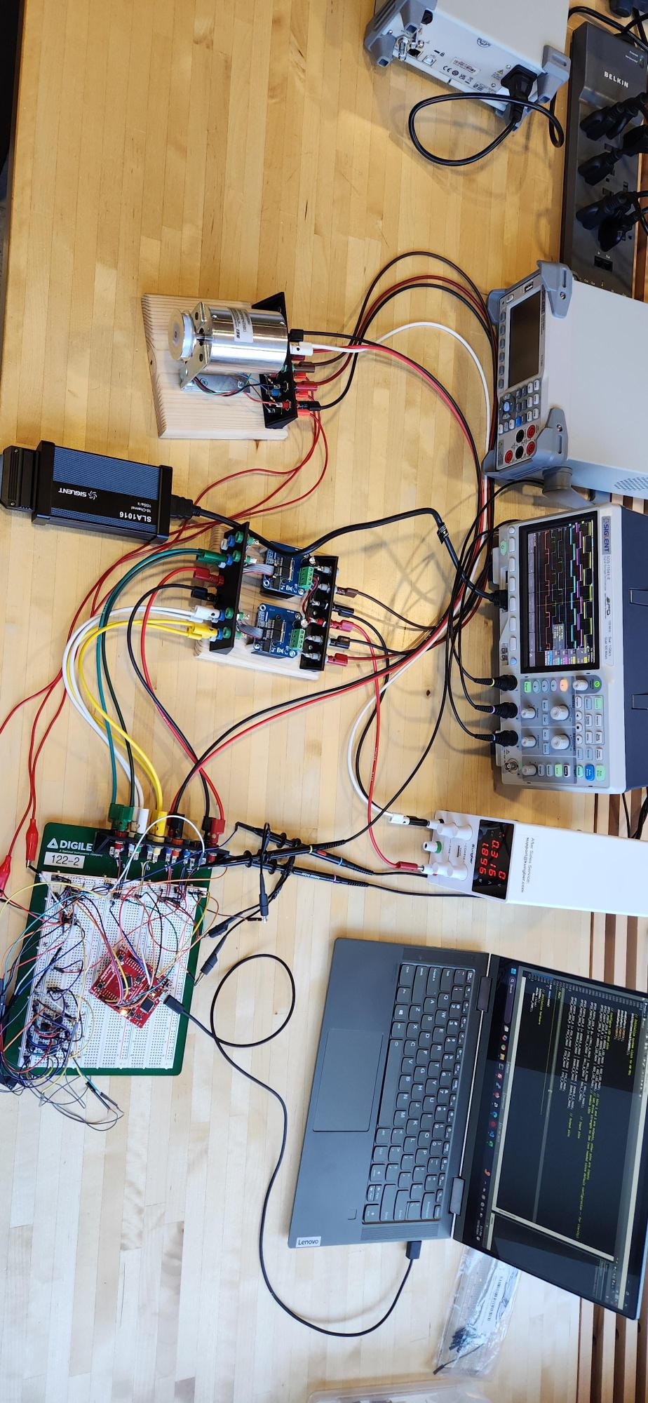
Figure 7: Final setup as used for lab demo

